fall 2024
Cse-4355/5355 Electromechanical Systems and Sensors
the university of texas at arlington


lab 8 - report
Submitted toward the partial completion of the requirements for CSE 4355/5355
Under the guidance of
Prof. Jason Losh
By:
Dario Ugalde, 1001268068
Joshua Martinez, 1001374818

Introduction
Light Detection and Ranging (LiDAR) sensors are a detection system which works on similar principles as radar but uses light instead of radio waves. Such devices are used in various fields to measure precise distances of their specified areas. Within this lab, we explored using the application of lidar through the RPLIDAR A1, model A1M8. This is a 360-degree laser scanner based on LiDAR. It uses a laser triangulation measurement system, which outputs a laser at various angles during rotation. For it to find the distance of one of these outputs, the value is calculated based on the corresponding sensors when these lasers reflect toward the device. The main objective of this lab is to understand this sensor’s connections, interfacing, and usage to approximate the dimensions of a room.

A1M8 Connections
Using the TM4C123GXL red board, UART0, UART1, and a PWM0_1A were configured during the hardware initialization. UART0 is used to provide user feedback via serial console, such as putty. UART1 is used to interface with the A1M8 sensor and request operation of the sensor’s various functions which for this lab include START, INFO, and SCAN. These will be described in greater detail in the following section. The A1M8 sensor has 2 hardware interfaces: motor and core.
The motor interface consists of 3 pins, VMOTO, MOTOCTL, and GND. VMOTO is a 5V source used to power the device, provided by VBUS of the TM4C123GXL. MOTOCTL is the PWM signal used to rotate the sensor’s motor and is provided by the red board PWM0_1A module. GND is the ground pin for the sensor and is shared with the red board ground pin.
The core interface consists of 4 pins, VCC_5, TX, RX, and GND. VCC_5 is also provided by the red board VBUS. TX is connected to the PC4 pin, the UART1 receive pin of the red board. RX is connected to the PC5 pin, the UART1 transmit pin of the red board. GND of the core interface is also connected to the ground of the red board. Using this hardware configuration enables usage of the various functions of the A1M8 sensor.

A1M8 Interface
The A1M8 software interface is based on a request/response system. As mentioned before, this lab will revolve around the usage of the START, INFO, and SCAN requests.
The START request is made by sending the bits [0xA5, 0x25] via the UART1 TX pin. This request puts the lidar in the idle state. A 1ms delay is expected before sending any additional requests.
The INFO request is made by similarly sending the bits [0xA5, 0x50]. This request will has a 20-byte response that provides the device’s model number, firmware version, and serial number.
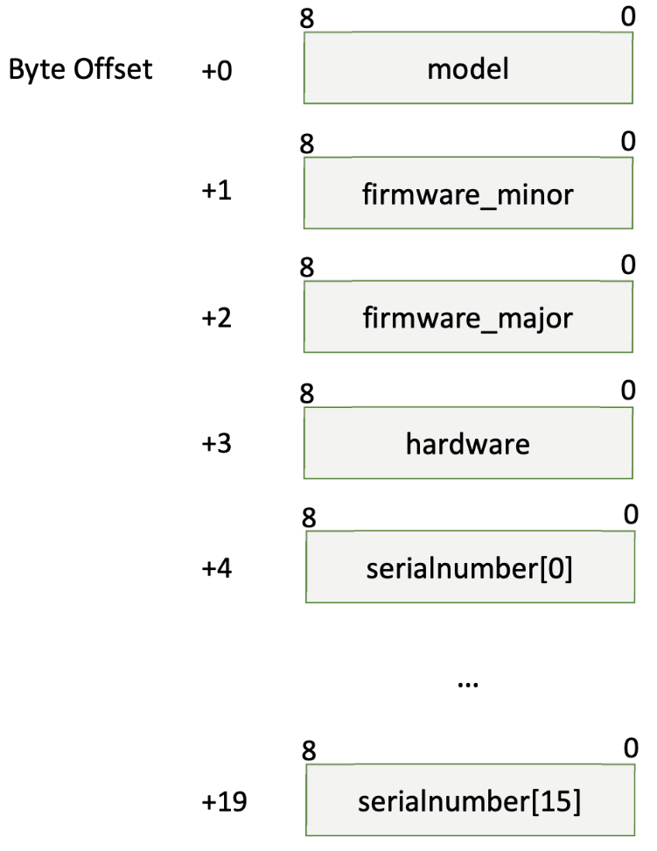
Figure 1. 20-byte INFO response format
Finally, the SCAN request is made by sending [0xA5, 0x20] via the UART1 TX pin. This request has a 5-byte response as shown in the image below. According to the datasheet, data is sampled for the scan message at 4 KHz. This request is a continuous output of data from the core which requires specific handling.
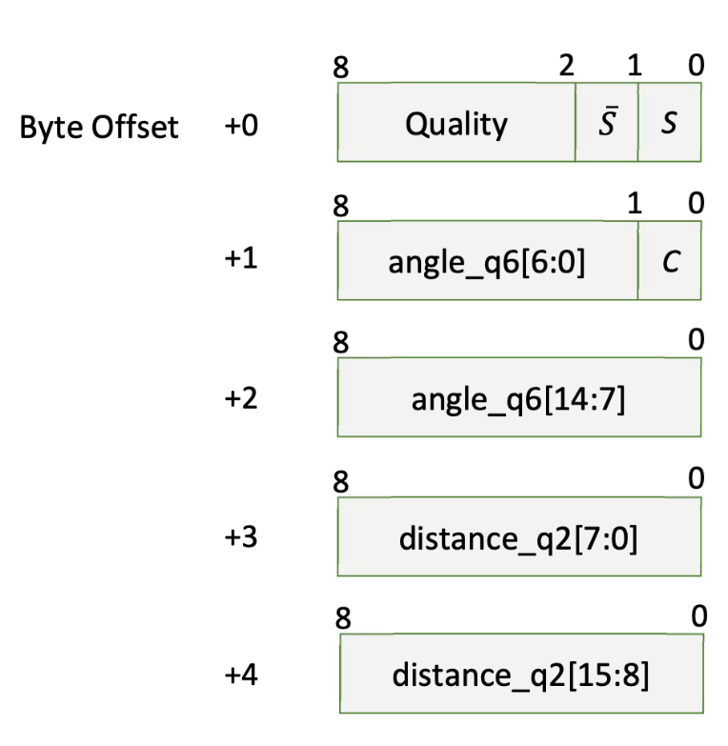
Figure 2. 5-byte SCAN response format

Calculating Room Dimensions with A1M8
As mentioned, the data output from certain requests requires special handling. In our case, we decided to use a struct to parse and organize our retrieved data based on the request. Once the structs for necessary messages were defined, development of the software could begin. Our solution begins by confirming the device’s version data by making an INFO request and storing the response data in a local struct. This data is parsed and presented to the user via UART0 as visual feedback. The PWM module then begins rotating the lidar and the SCAN request is sent. To not lose any UART data, it is necessary to immediately read data from the RX line of UART1. After reading the 7-byte response descriptor we enter a loop that reads 360 response payloads. Each of the response messages are parsed and the angle data and the distance data are stored in our corresponding arrays.
With the arrays now full, the next step is to provide the user with visual feedback of the captured data via UART0 to be logged. This will allow for the creation of the required polar plot shown below in Figure 3. Finally, a for loop was used to iterate over all the captured points and perform the summation of the area of the room. In our case, we measured the area of the room at 39,321.66in².

Figure 3. Polar Plot of Lidar Data

Conclusion
This lab introduced us to the basic applications of LiDAR sensors. To operate the RPLIDAR device in this lab, it required the use of a UART connection to send and receive data alongside an active PWM connection to rotate the device. By leveraging the datasheet of the device and our prior knowledge of the TM4C, we were able to utilize the A1M8 lidar sensor to measure various distances around the lab space to calculate it’s area. Many LiDAR devices used today offer 3D point clouds but this lab served as a foundation on understanding how lidars work in principle and how we might go about interfacing with them in the future.

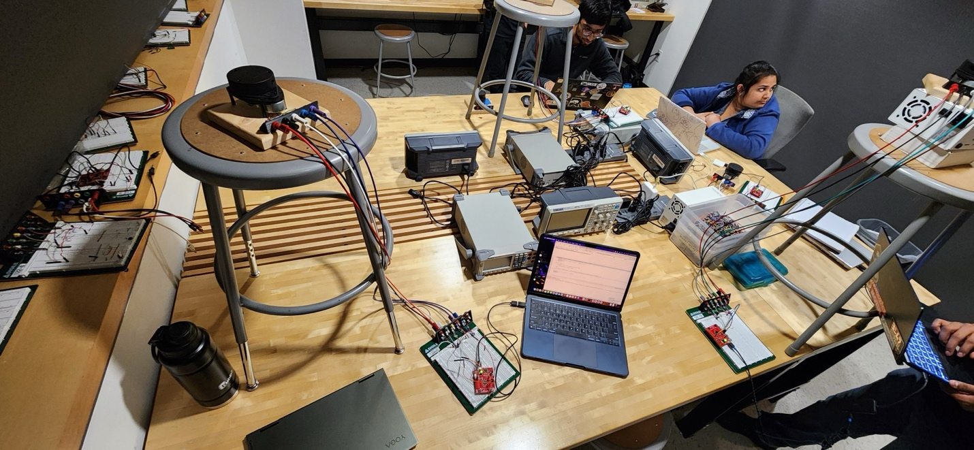
Figure 4. Setup used to complete lab 8

